Katerina Betts and Donald Hutchinson

Professor Charles Zimmer

Data Structures

6 February 2018

Lab Four: Classes, Multi-File Programs, and Operating Overloading

When initially designing the class, each element of vector addition, subtraction, division and multiplication was taken into account as well as the necessary attributes in the private section of the class. The hardest part in this lab was interpreting what was necessary in the class based on the instructions given. Whether or not to implement two different vectors within the class was one obstacle that needed to be overcome and decided upon before getting to the overloading task in the lab. It was hard to understand how two vectors were supposed to be implemented without the overloading aspect of the lab, and at first there were two x’s and y’s in order to account for two vectors in one class. However, after careful consideration of the overloading task, it was concluded that the class would be better suited to holding one single vector and creating multiple objects due to the difficulty in using multiple vectors within the class. The parts of the class that were important to consider were which attributes needed to be private or public, how many constructors were needed and how they would be utilized, and the amount of different functions that needed to be implemented in the class. In this case, all the variables were private in this class and the functions were in the public section. The constructors had to follow the parameters given in the lab report; therefore, there are only three in the class: the default constructor, a constructor that takes in magnitude and angle, and one that takes in the x and y attributes. The get and set functions were written into the class in order to be able to get the values of the private variables and also set those same variables in the class. The overloads were also written in the way the given in the lab document as well and are public.

The program was written in Cloud9 and then transferred to Visual Studio Community as it was the standard IDE, and less people know how to use Cloud9 than Visual Studio.

Figures 1 and 2: Add and Subtract

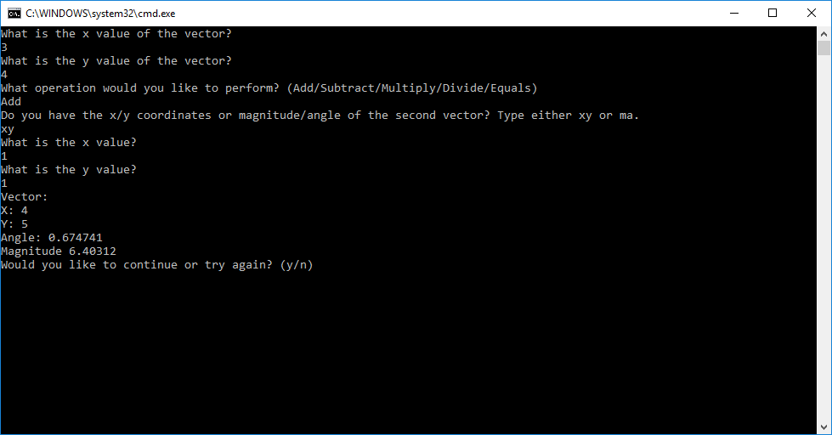

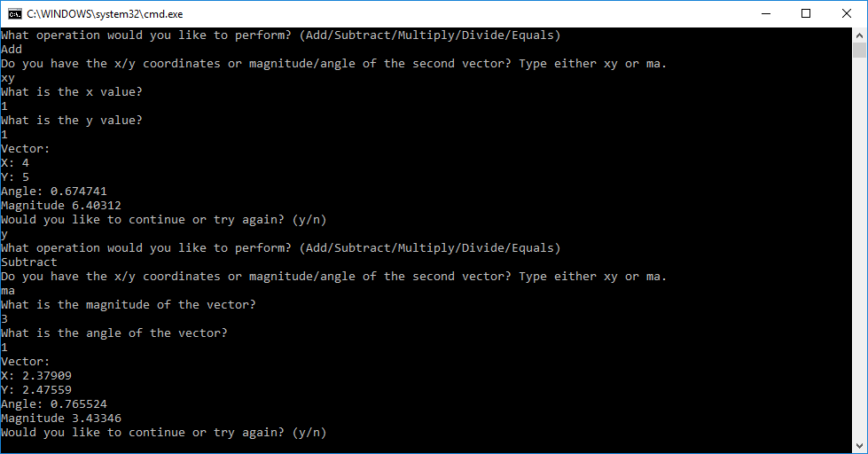

*Figure 1: Shows the results when the user wants to add two vectors.*

*Figure 2: Shows the results when the user wants to subtract two vectors*

Figures 3 and 4: Multiply and Divide

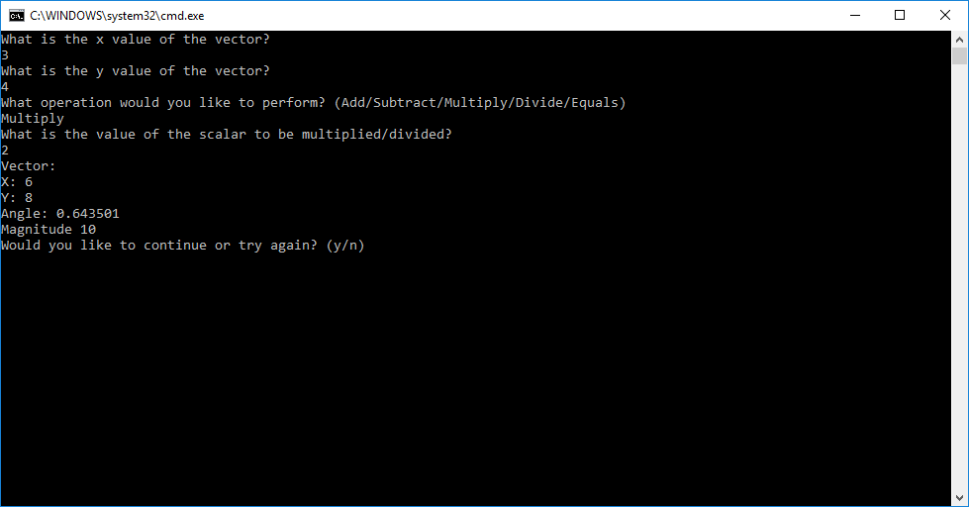

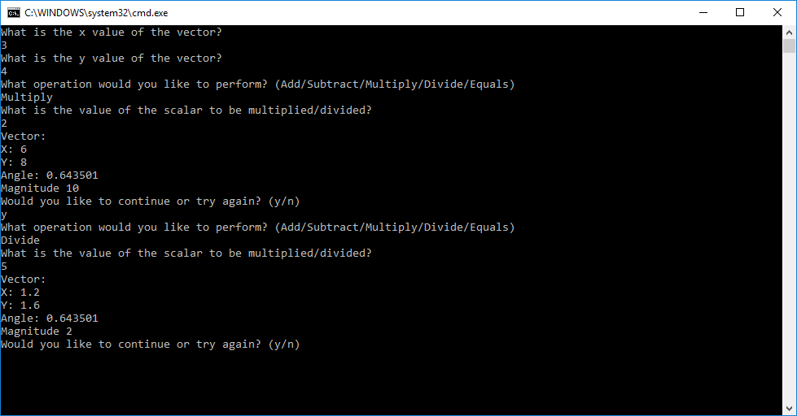

*Figure 3: Shows the results when a user wants to multiply by a scalar.*

*Figure 4: Shows the results when a user wants to divide by a scalar*

Figure 5: Equals

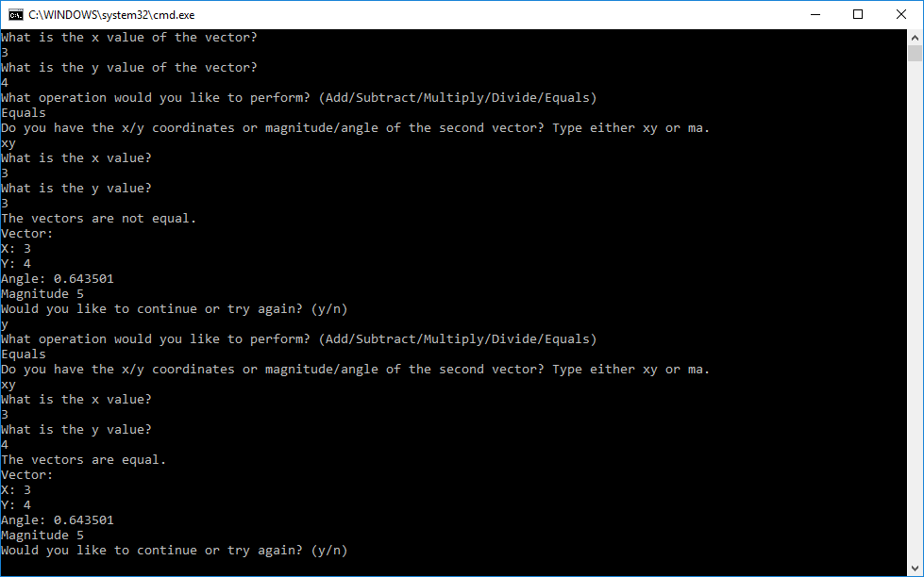

*Figure 5: Shows the results when a user wants to know if two vectors are equal.*